How to install OpenNMS



Revision control
Date created | Last Modified
Maret, 28 2018

DINAS KOMUNIKASI DAN INFORMATIKA KOTA TANGERANG
2018

- Sebelum melakukan insallasi OpenNMS, pastikan sudah melakukan konfigurasi berikut:
- Setting IP (bias akses internet)
[root@opnms ~]# nano /etc/sysconfig/network-scripts/ifcfg-enp7s0f0

TYPE="Ethernet"
BOOTPROTO="static"
DEFROUTE="yes"
IPV4_FAILURE_FATAL="no"
IPV6INIT="yes"
IPV6_AUTOCONF="yes"
IPV6_DEFROUTE="yes"
IPV6_FAILURE_FATAL="no"
NAME="enp7s0f0"
UUID="b7465b0f-784a-43e7-b8ac-38e942557d10"
DEVICE="enp7s0f0"
ONBOOT="yes"
DNS1="27.50.20.21"
IPADDR="172.16.10.192"
PREFIX="24"
GATEWAY="172.16.10.1"
DNS2="166.66.200.66"
IPV6_PEERDNS="yes"
IPV6_PEERROUTES="yes"
IPV6_PRIVACY="no"
ZONE=public

- Download Script Installer OpenNMS & Execute Script tersebut
[root@opnms ~]# curl -L https://github.com/opennms-forge/opennms-install/archive/1.1.tar.gz | tar xz

[root@opnms ~]# cd opennms-install-1.1

[root@opnms opennms-install-1.1]# bash bootstrap-yum.sh

- Tunggu sampai proses installasi package selesai, setelah itu isikan password database OpenNMS
Complete!
OK
PostgreSQL initialize ... OK
PostgreSQL set auth from ident to md5 ... OK
Start PostgreSQL database ... OK
PostgreSQL systemd enable ... OK

Enter database username: pandora
Enter database password:

Generate OpenNMS data source config ... OK
Initialize OpenNMS ... OK
Starting OpenNMS ... OK
OpenNMS systemd enable ... OK

Congratulations
---------------

OpenNMS is up and running. You can access the web application with

http://this-systems-ip:8980

Login with username admin and password admin

Please change immediately the password for your admin user!
Select in the main navigation "Admin" and go to "Change Password"

Thank you computing with us.

- Setelah installasi selesai, akses webconsole OpenNMS menggunakan Browser.
http://this-systems-ip:8980

username: admin
password: admin

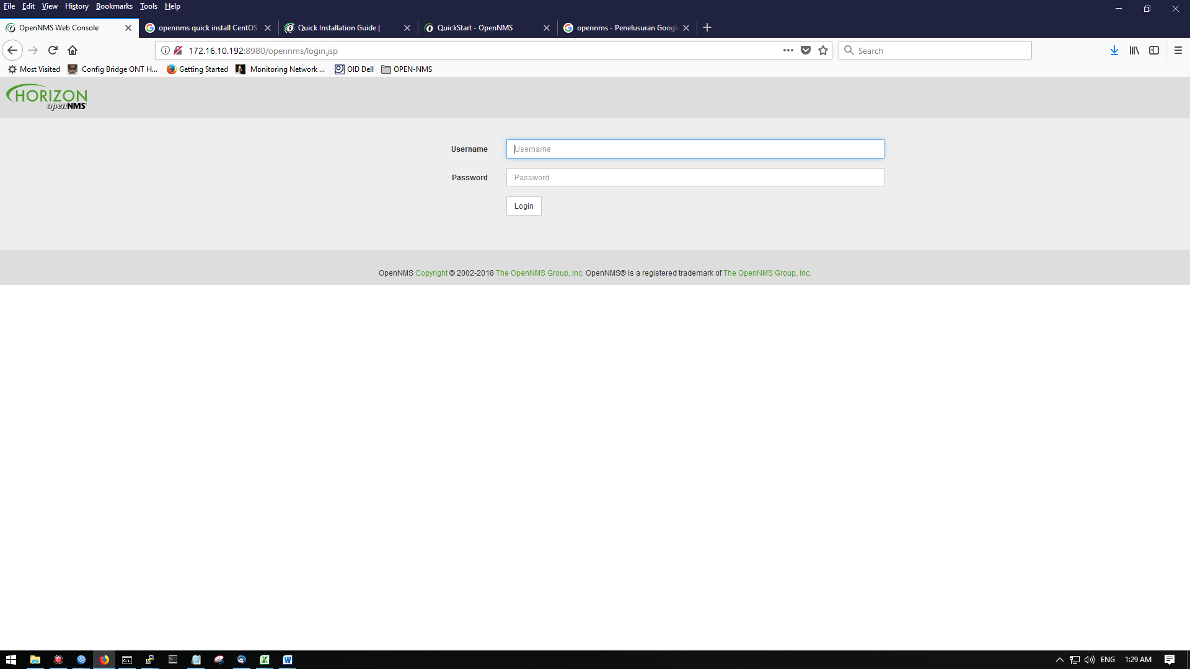

- Install SNMP
[root@email ~]# yum install net-snmp net-snmp-utils
Loaded plugins: fastestmirror
Loading mirror speeds from cached hostfile
* base: sumberterbuka.beritagar.id
* epel: epel.mirror.angkasa.id
* extras: sumberterbuka.beritagar.id
* updates: sumberterbuka.beritagar.id
Package 1:net-snmp-5.7.2-28.el7_4.1.x86_64 already installed and latest version
Resolving Dependencies
--> Running transaction check
---> Package net-snmp-utils.x86_64 1:5.7.2-28.el7_4.1 will be installed
--> Finished Dependency Resolution

Dependencies Resolved

====================================================================
Package Arch Version Repository Size
===================================================================
Installing:
net-snmp-utils x86_64 1:5.7.2-28.el7_4.1 updates 198 k

Transaction Summary
====================================================================
Install 1 Package

Total download size: 198 k
Installed size: 408 k
Is this ok [y/d/N]:y

KONFIGURASI

- Configure SNMP Agent
Klik Configure OpenNMS Configure SNMP Community Names by IP Address

Isi kolom berikut
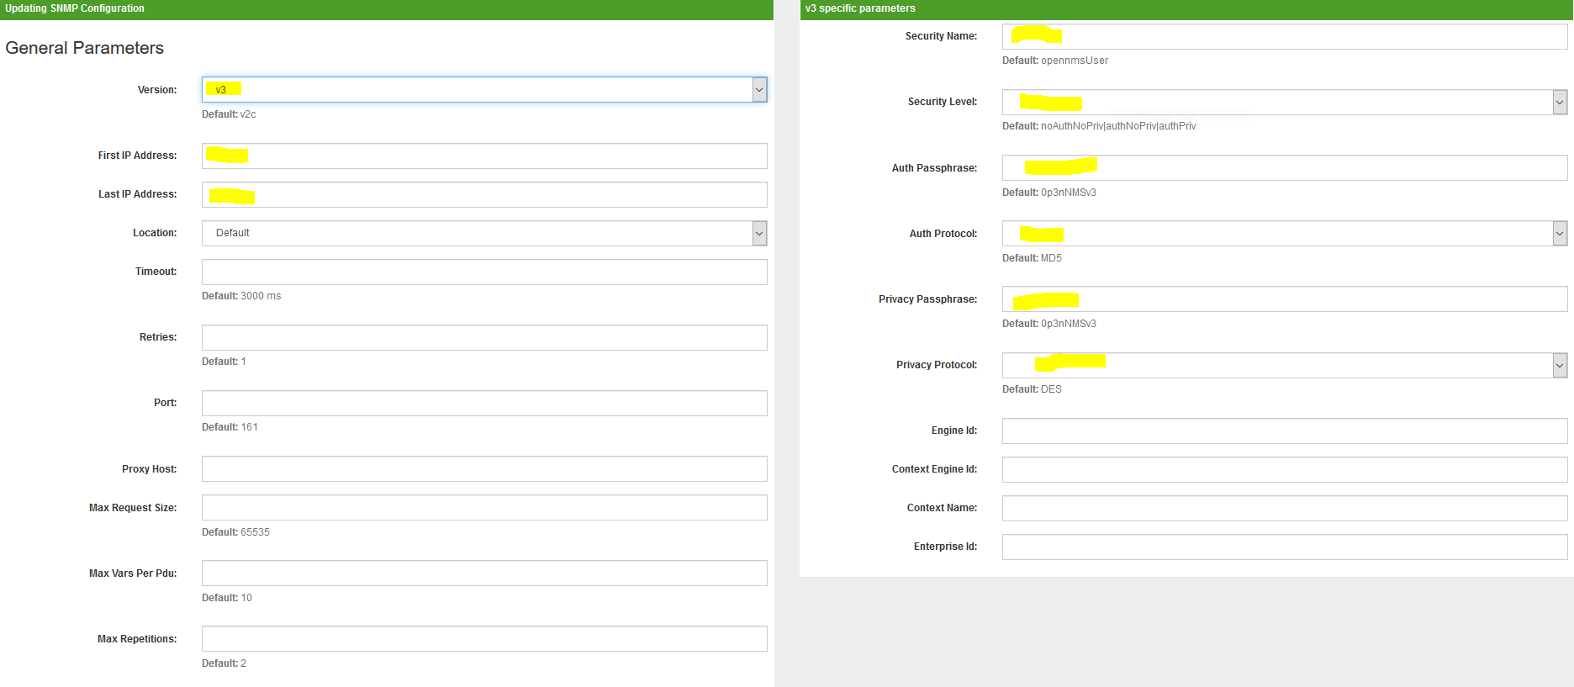

- Configure Discovery
Klik configure OpenNMS

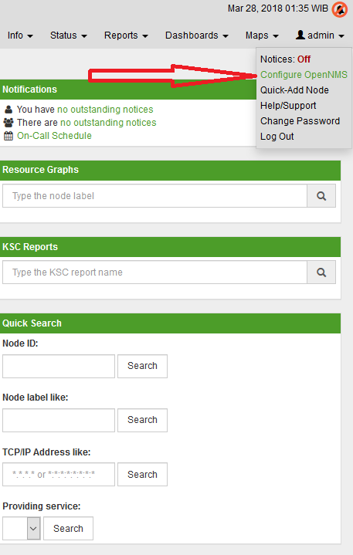
Pilih Configure Discovery
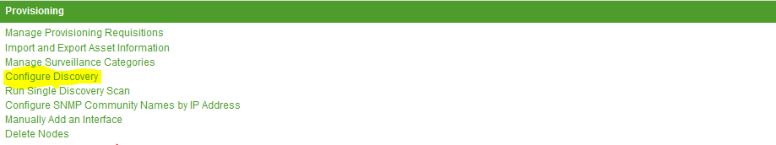

Pilih Include Ranges Add New

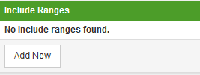

Masukan Range network yang akan di scanning snmp nya
